Databricks Setup on AWS
The setup involves three main phases:
Phase 1: AWS Account Preparation: You will create the necessary resources and permissions within your AWS account that Databricks will use. This includes an S3 bucket for storage and IAM roles for secure access.
Prerequisites: The guide correctly identifies the necessary prerequisites, including an active AWS account and an IAM user with AdministratorAccess permissions for the setup.
S3 Bucket Creation: The instructions for creating a root S3 bucket are detailed and follow best practices. The guide explains that this bucket is used for storing essential artifacts like logs, notebooks, and job results. It rightly emphasizes the critical importance of creating the bucket in the same region as the planned Databricks workspace.
IAM Role Creation: The use of Databricks's pre-built CloudFormation template to create IAM roles is an excellent, standardized approach. The steps are clear:
- Launch the template from the Databricks Account Console.
- Configure the stack by providing the ExternalId (your Databricks Account ID).
- Acknowledge the creation of IAM resources and create the stack.
- Retrieve the essential CrossAccountIamRoleArn and InstanceProfileArn from the stack outputs after creation is complete.
Phase 2: Databricks Workspace Deployment: You will use the Databricks Account Console to launch a new workspace, linking it to the resources you created in AWS.
Configuration: The instructions to configure credentials by pasting the CrossAccountIamRoleArn and to set up storage using the S3 bucket name are straightforward.
Workspace Creation: The guide clearly lists the details needed to create the workspace, such as the name, region, and the credential and storage configurations selected previously.
Deployment: The document correctly sets the expectation that the deployment process takes 10-15 minutes and can be monitored on the Workspaces dashboard.

Phase 3: Post-Deployment Configuration: Once the workspace is running, you will perform initial setup tasks like creating a compute cluster and managing users.
User Management: The guide provides clear instructions for accessing the workspace and adding new users through the Admin Settings. It also includes the best practice of creating groups for managing permissions.
Cluster Creation: The steps for creating a compute cluster are well-defined. The guide explains key settings like cluster mode, runtime version, and EC2 instance types. Importantly, it highlights the cost-saving practice of enabling auto-termination for inactive clusters.
Verification: The guide concludes with an excellent final verification step: creating a notebook and running a simple PySpark code snippet. This effectively confirms that the entire setup is functioning correctly.

Phase 1: AWS Account Preparation
Before you can deploy Databricks, you must configure your AWS account.
Prerequisites
- An active AWS account.
- An IAM user with AdministratorAccess permissions in your AWS account to perform these one-time setup steps.
Step 1: Create a Root S3 Bucket
Databricks requires a dedicated S3 bucket in your AWS account to store essential artifacts. This "root bucket" will hold cluster logs, notebook revisions, job results, and other data.
- Navigate to S3: Log in to your AWS Management Console and go to the S3 service.
- Create Bucket: Click on the Create bucket button.
- Configure Bucket:
  - Bucket name: Choose a globally unique name. It's a good practice to include the region and purpose, for example: databricks-root-storage-us-east-1.
  - AWS Region: Select the region where you plan to deploy your Databricks workspace. This is important! The S3 bucket and the Databricks workspace must be in the same region.
  - Block Public Access: Leave the "Block all public access" settings checked (default). This is the secure option.
  - Bucket Versioning & Tags: You can leave these as default for now.
- Click Create bucket. Note down the name of this bucket, as you will need it later.
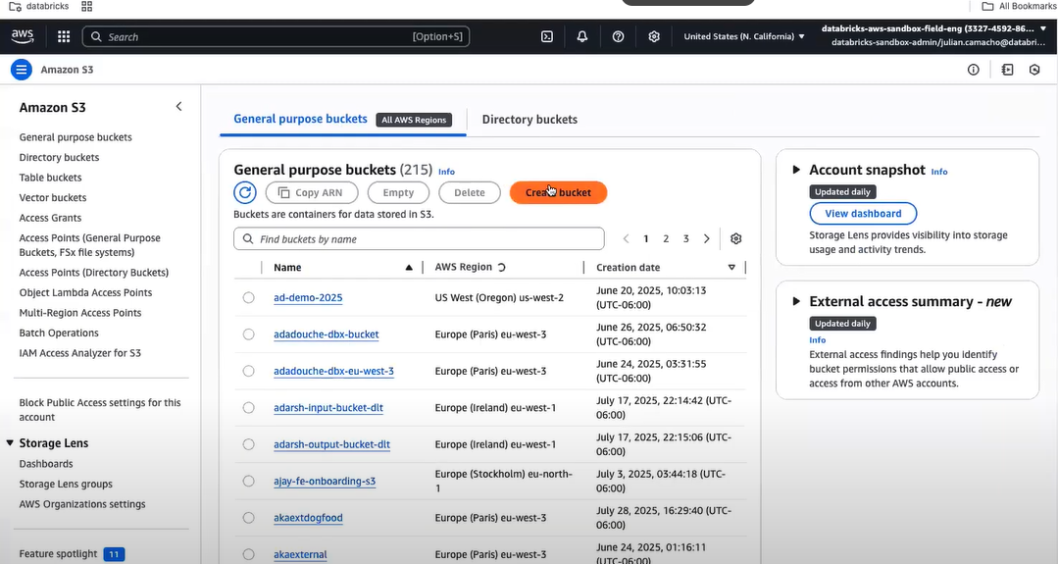
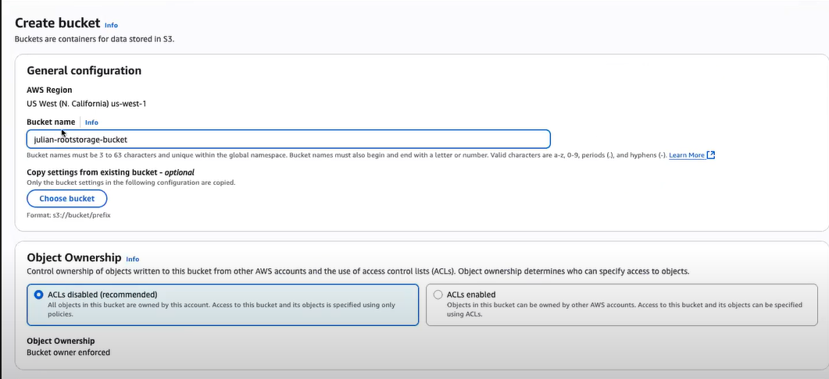
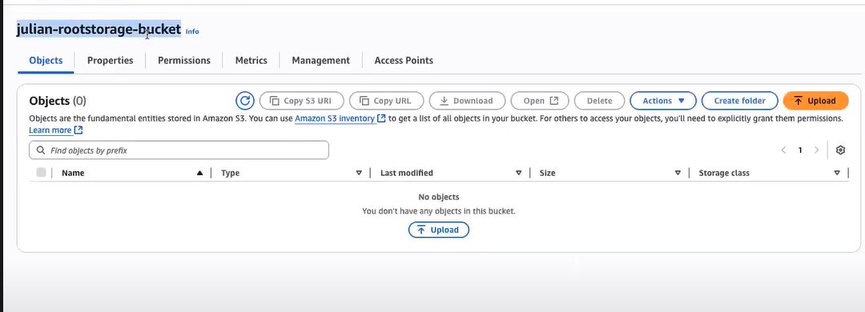
Step 2: Create AWS IAM Roles and Policies
Databricks interacts with your AWS account using secure IAM roles. You will create two primary roles using AWS CloudFormation for simplicity and accuracy.
Databricks provides a pre-built CloudFormation template to create these roles automatically.
- Launch the CloudFormation Template:
  - Log in to your Databricks account at https://accounts.cloud.databricks.com. If you don't have one, sign up for a trial.
  - In the left sidebar, click on Cloud Resources.
  - Click Create credential configuration.
  - Give it a Credential configuration name (e.g., MyCompany-AWS-Creds).
  - A link will appear: Open AWS Quickstart template. Click this link. This will take you directly to the AWS CloudFormation "Create stack" page with the Databricks template pre-loaded.
- Execute the CloudFormation Stack:
  - The template URL will be filled in. Click Next.
  - On the Specify stack details page:
    - Stack name: It will have a default name like databricks-iam-role-creation. You can keep it.
    - Parameters: You will see a parameter named ExternalId. Go back to your Databricks credential creation page. You will find your Databricks Account ID there. Copy this ID and paste it into the ExternalId field in the CloudFormation template.
  - Click Next.
  - On the Configure stack options page, you can leave the defaults. Click Next.
  - On the final Review page, scroll to the bottom and check the box that says, "I acknowledge that AWS CloudFormation might create IAM resources with custom names."
  - Click Create stack.
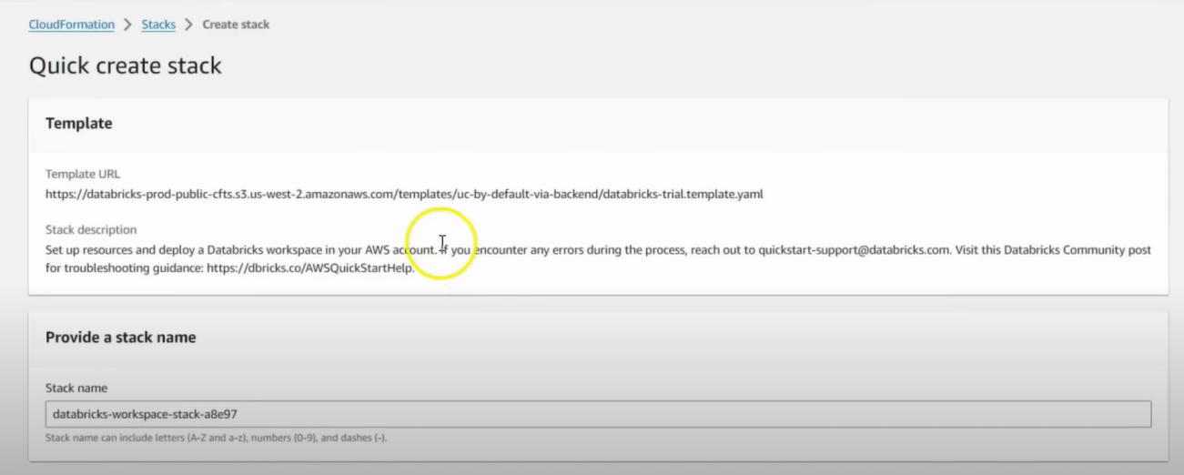

- Retrieve Role ARNs:
  - The stack creation will take a few minutes. Once the status shows CREATE_COMPLETE, go to the Outputs tab of your newly created stack.
  - You will see two key-value pairs. You need to copy and save the Value for both:
    - CrossAccountIamRoleArn: This role allows the Databricks control plane to manage resources in your account.
    - InstanceProfileArn: This role is attached to the EC2 instances (your clusters) to allow them to access the root S3 bucket.
You have now completed the AWS preparation. You have the S3 bucket name, the Cross-Account Role ARN, and the Instance Profile ARN.
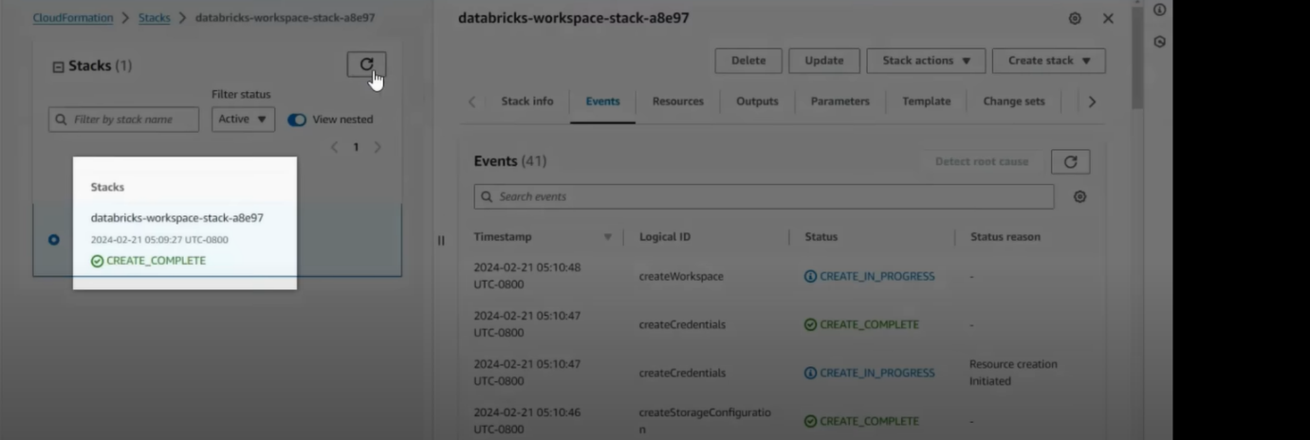

Phase 2: Databricks Workspace Deployment
Now you will use the information from Phase 1 to deploy the workspace from the Databricks Account Console.
Step 3: Configure Credentials in Databricks
- Go back to the Databricks "Create credential configuration" page you had open.
- Paste the CrossAccountIamRoleArn you copied from the CloudFormation outputs into the Role ARN field.
- Click Add.
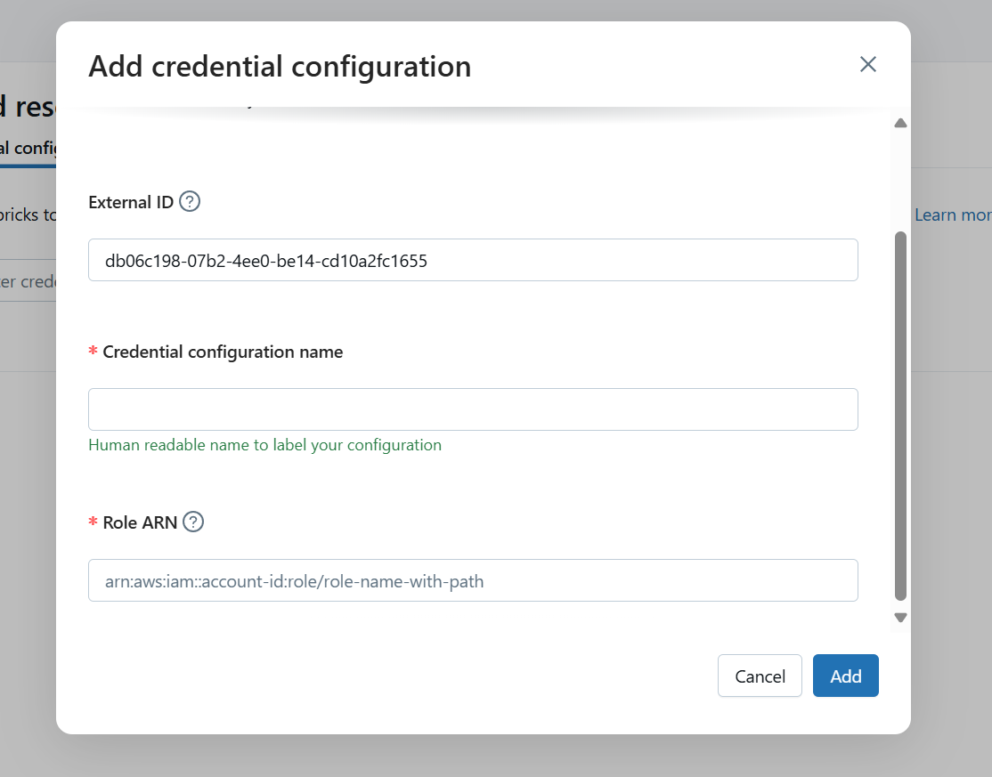
Step 4: Configure Storage in Databricks
- In the Databricks Account Console, navigate to Cloud Resources in the left sidebar.
- Click on the Storage configurations tab.
- Click Add storage configuration.
- Storage configuration name: Give it a descriptive name (e.g., MyCompany-Root-S3-Storage).
- Bucket name: Enter the exact name of the S3 bucket you created in Step 1 (e.g., databricks-root-storage-us-east-1).
- Click Add.
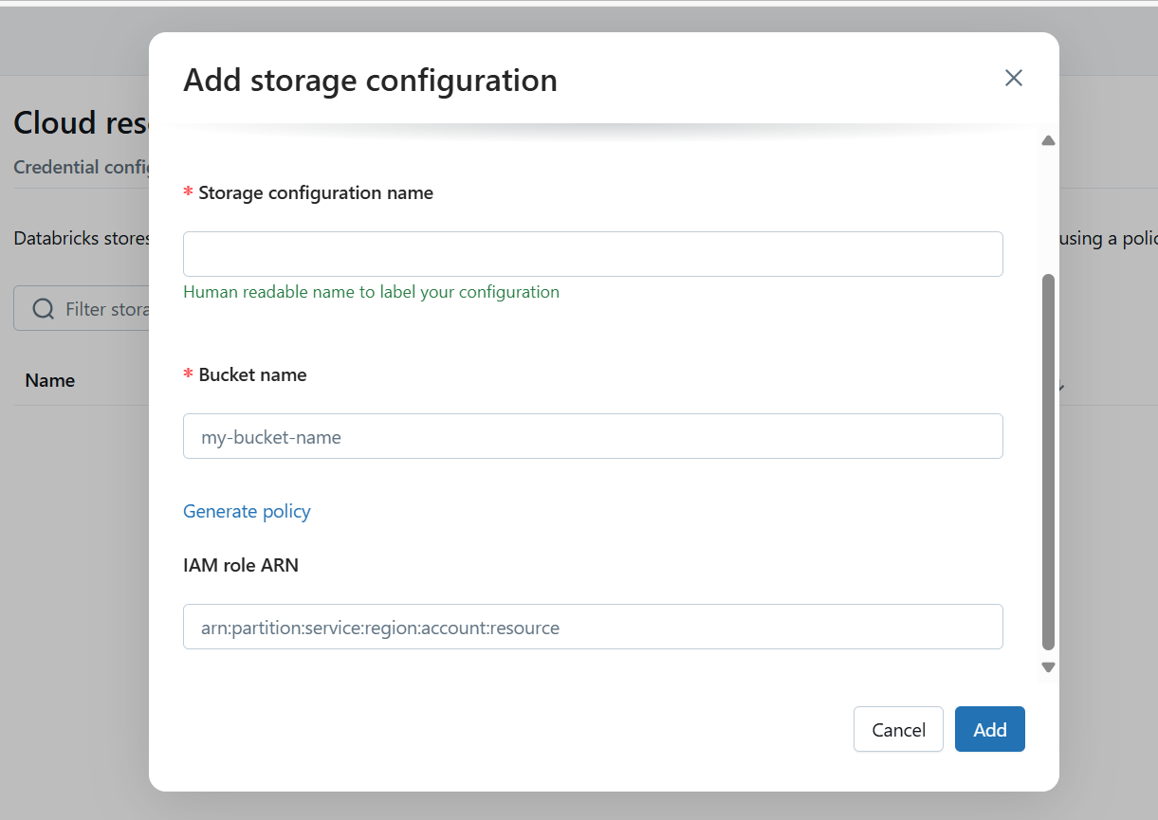
Step 5: Create the Databricks Workspace
This is the final step to launch your environment.
- In the Databricks Account Console, navigate to Workspaces.
- Click Create workspace.
- Fill in the workspace details:
  - Workspace name: A user-friendly name for your workspace (e.g., Development-Workspace).
  - AWS Region: Crucially, select the same region where you created your S3 bucket.
  - Credential configuration: Select the credential configuration you created in Step 3.
  - Storage configuration: Select the storage configuration you created in Step 4.
- Networking (Optional but Recommended):
  - For a simple setup, you can let Databricks create a new VPC for you.
  - For production environments, you would typically use your own VPC. This requires providing VPC ID, Subnet IDs, and Security Group IDs. For this guide, the default is sufficient.
- Click Confirm.
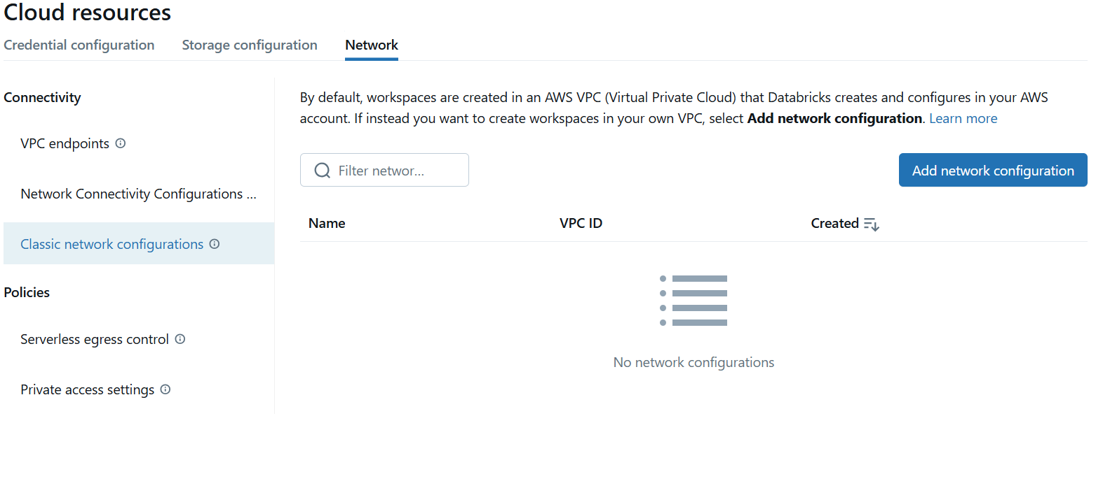
The deployment process will now begin. It typically takes about 10-15 minutes. Databricks uses the IAM role to provision all the necessary resources (VPC, security groups, EC2 instances for the control plane) in your AWS account. You can monitor the status on the Workspaces dashboard.

Phase 3: Post-Deployment Configuration
Once the workspace status is "Running," you are ready to use it.
Step 6: Access Your Workspace and Add Users
- On the Workspaces dashboard, click the Open button next to your new workspace. This will launch the workspace URL (e.g., https://my-company.cloud.databricks.com).
- You will be logged in as the account administrator.
- To add more users, go to the Admin Settings (click your email in the top right).
- Go to the Users tab and click Add User. Enter their email address. They will receive an invitation to set up their password.
- It's best practice to create groups (under the Groups tab) to manage permissions collectively.
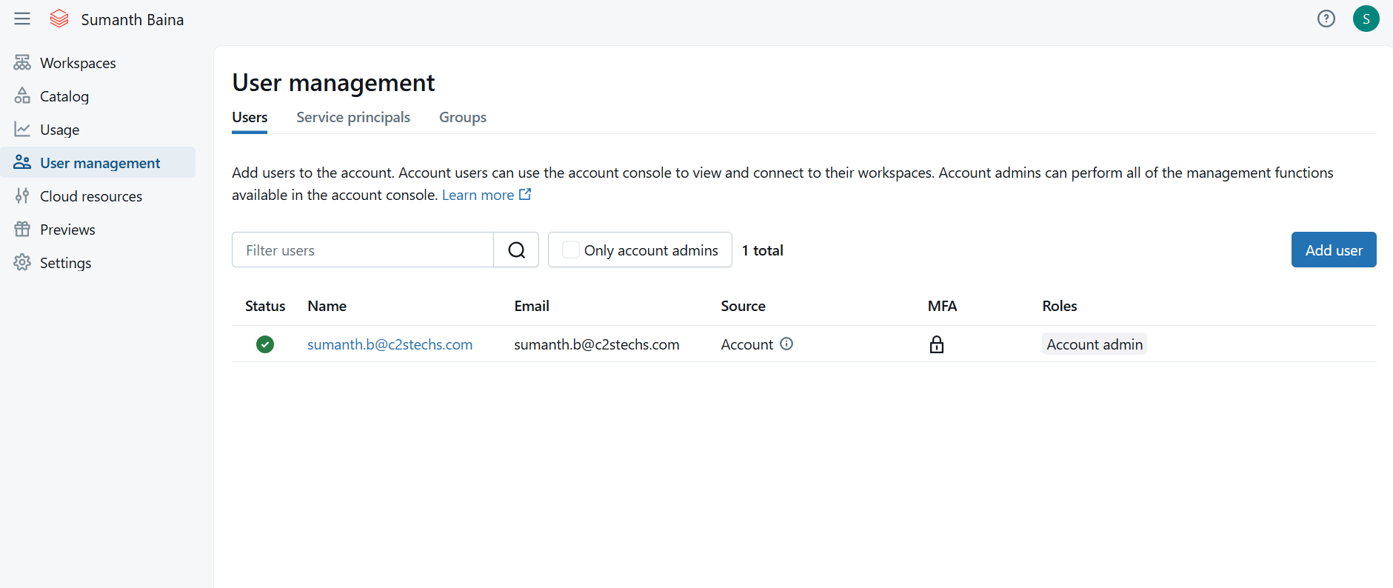
Step 7: Create Your First Compute Cluster
You need a cluster (a set of EC2 instances) to run any code.
- In the left sidebar of your workspace, click Compute.
- Click Create Cluster.
- Configure the cluster:
  - Cluster name: Give it a name (e.g., my-first-cluster).
  - Cluster mode: For learning, Single Node is cheapest. For real work, use Standard.
  - Databricks Runtime Version: Choose a recent LTS (Long Term Support) version.
  - Worker Type & Driver Type: These are the EC2 instance types. You can start with a general-purpose type like m5d.large.
  - Terminate after __ minutes of inactivity: Enable this! Set it to something like 30 or 60 minutes to automatically shut down the cluster when not in use and save costs.
- Click Create Cluster. It will take a few minutes for the EC2 instances to launch and for the cluster to become available.
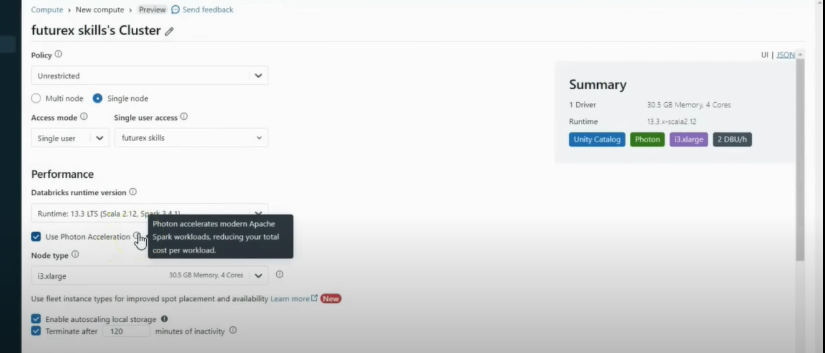
Step 8: Run Your First Notebook
- In the left sidebar, click + New and select Notebook.
- Give the notebook a name, leave the default language as Python, and select the cluster you just created from the dropdown at the top.
- In the first cell, enter some simple PySpark code:
Python
# Create a sample DataFrame
data = [("Alice", 1), ("Bob", 2), ("Charlie", 3)]
columns = ["name", "id"]
df = spark.createDataFrame(data, columns)
# Display the DataFrame
display(df)
- Press Shift + Enter to run the cell. The first time you run a command, it may take a moment as the Spark session starts. You should see a formatted table with the data you defined

Sources
1 https://youtu.be/gEDS5DOUgY8?si=vZ2_j_PaOK_5NpUo
2 Create a workspace using the AWS Quickstart (Recommended) | Databricks on AWS

